10 FTP Sampler

This section will guide you:

* To understand FTP Sampler

**Development Environment:**

* Apache JMeter 5.1.1 Version

This guide has five sub-sections, namely:

1.10.1 Adding users in the thread group

1.10.2 Adding Default FTP Request Properties

1.10.3 Adding FTP Request

1.10.4 Adding Listener and viewing the results in a table

1.10.5 Pushing the code to your GitHub repositories

**Steps 1.10.1:** Adding users in the thread group

* Open JMeter.
* Right click on **Test Plan**.
* Select **Add** → **Thread Group.**

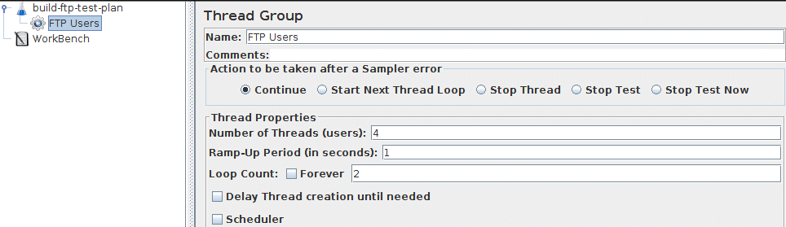

**Steps 1.10.2:** Adding Default FTP Request Properties

* + Right click on **Test Plan.**
  + Select **Add** → **Config Element** → **FTP Request Defaults.**

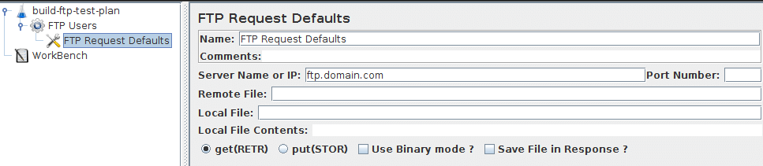

**Steps 1.10.3:** Adding FTP Request

* Select Add → Sampler → FTP Request.

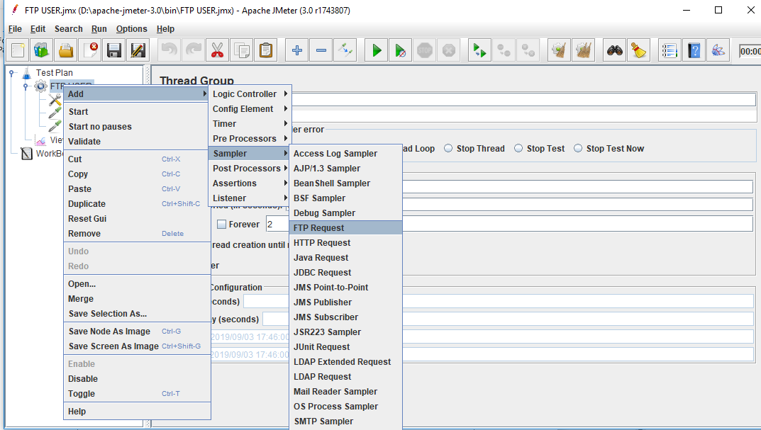

* Change the name to ‘File1.’
* Change the Remote File field to ‘/directory/file1.txt.’
* Change the Username field to ‘anonymous.’
* Change the Password field to ‘anonymous@test.com.’

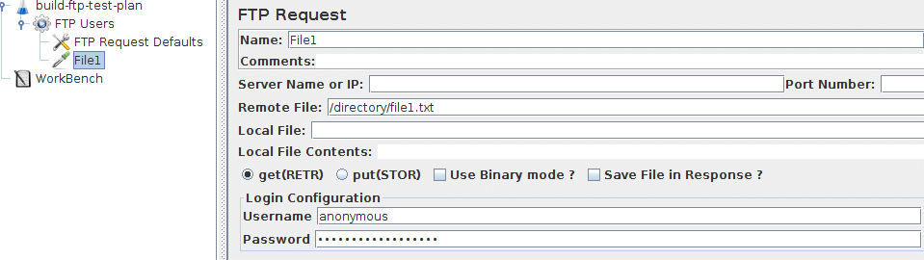

**Steps 1.10.4:** Adding Listener and viewing the results in a table

* Right click on Test Plan.
* Select Add → Listener → View Results in the table.

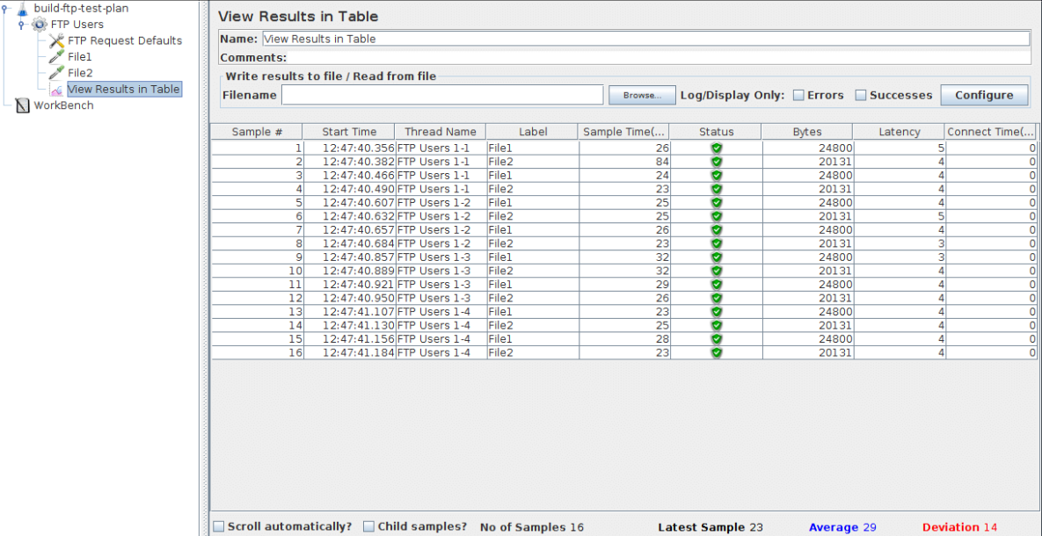

**Steps 1.10.5:** Pushing the code to your GitHub repositories

Open your command prompt and navigate to the folder where you have created your files.

cd <folder path>

Initialize your repository using the following command:

git init

Add all the files to your git repository using the following command:

git add 

Commit the changes using the following command:

git commit . -m “Changes have been committed.”

Push the files to the folder you initially created using the following command:

git push -u origin master